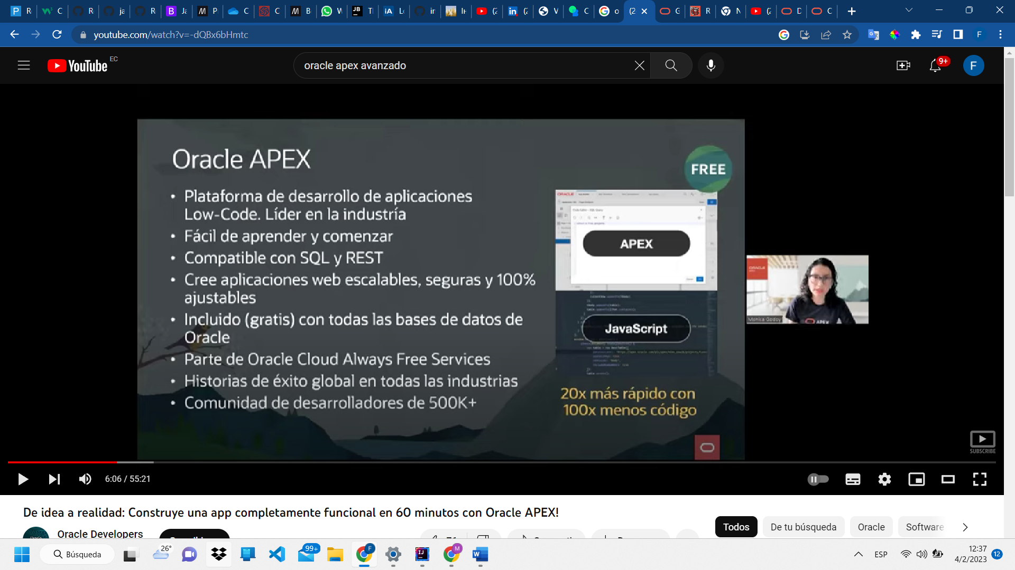

Creando table con RUN SQL

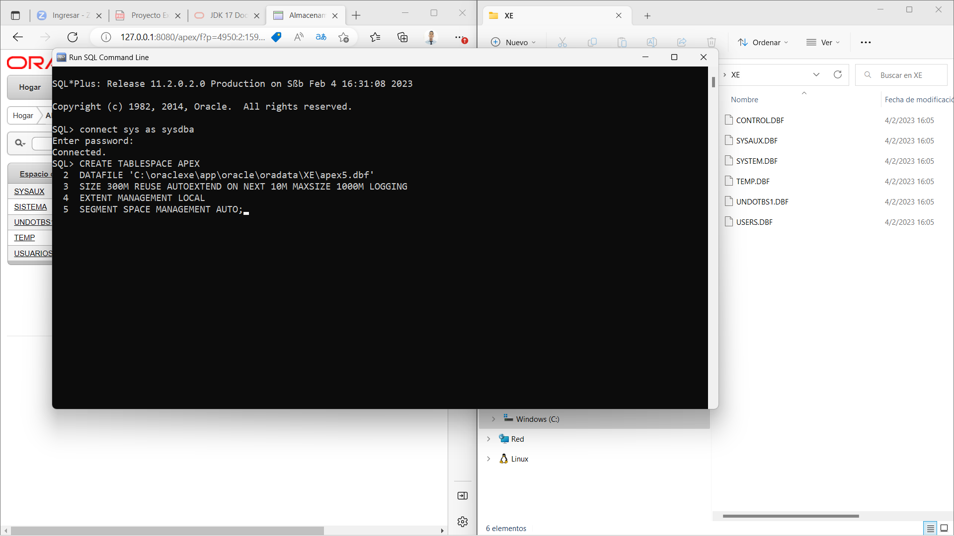

CMD WINDONS INSTALACION APEX

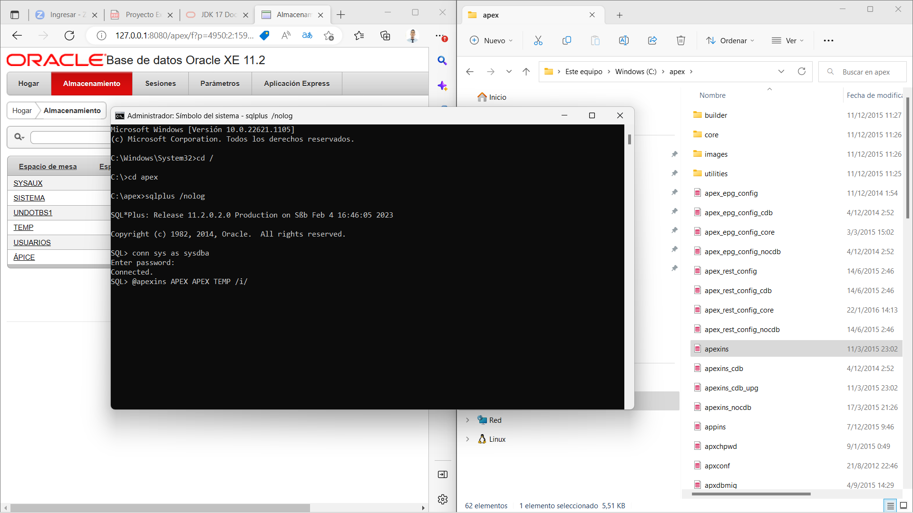

Ver puerto

select dbms_xdb.gethttpport from dual;

Creando Wordspace

